**Question**

**Users can put a compressed file at any path of the linux file system. The name of the file will be research and the extension will be of compression type, example for gzip type extension will be .gz.**

**You have to find the file and check the compression type and uncompress it.**

**My Approach**

**Step 1 : Open terminal**

**Step 2 : Type the given command**

**Command = sudo find / -name "research.tar" -exec sh -c 'echo "Uncompressing {} at $(dirname {})" && tar -xvf "{}" -C "$(dirname {})"' \;**

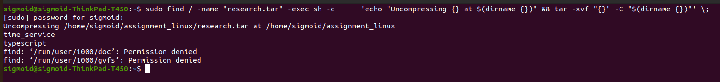

**Note =** The provided command is a sudo-privileged operation that searches for files named "research.tar" within the /home/sigmoid directory and its subdirectories. For each occurrence found, it prints a message indicating that it's uncompressing the file, and then proceeds to extract the contents of the tar file into the directory where the tar file is located.